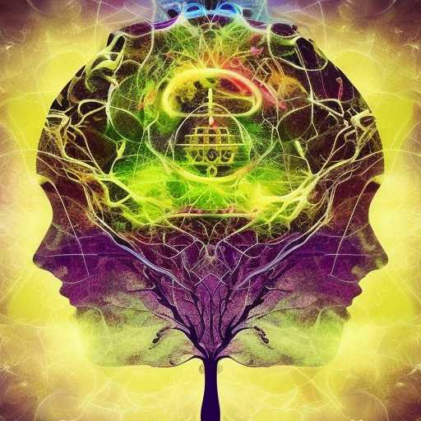
DIVINE LANDSCAPES

We all must dream into the void our most beautiful feelings and thoughts
We can feed the machine our poison, or we can form a mutually inspiring Tree of Wisdom and Bliss
Together

AI is already creating things beyond man’s mind
Best dig deep within ourselves to find the highest
aspirations and the Most Triumphant Exultation of our Souls

God is Omniscient
We should not worship AI or its creations
Rather, we should work with AI to create Divine Landscapes

